1) Find all branch names and cities with assets more than 1000000. (on single table)
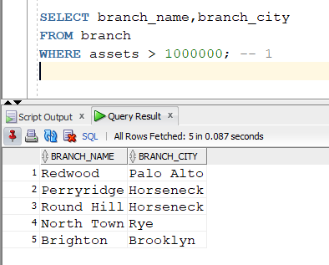
2) Find all account numbers and their balance which are opened in ‘Downtown’ branch or which have balance in between 600 and 750. (on single table)
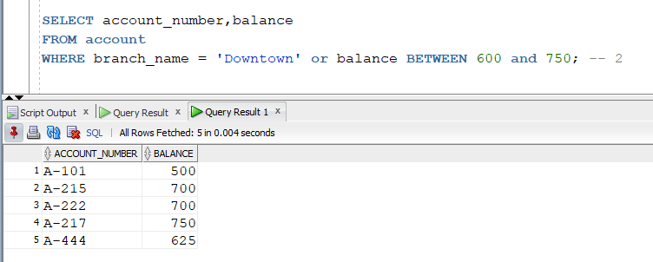

3) Find all account numbers which are opened in a branch located in ‘Rye’ city. (multiple tables)
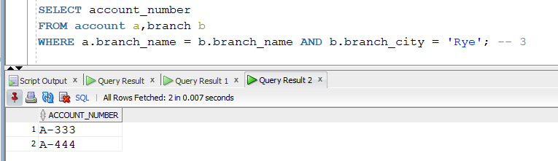
4) Find all loan numbers which have amount greater than or equal to 1000 and their customers are living in ‘Harrison’ city. (multiple tables)
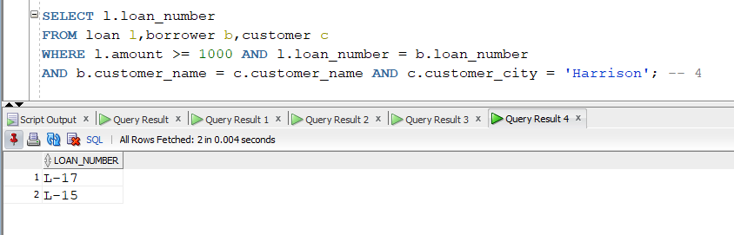

5) Display the account related information based on the descending order of the balance. (order by clause)
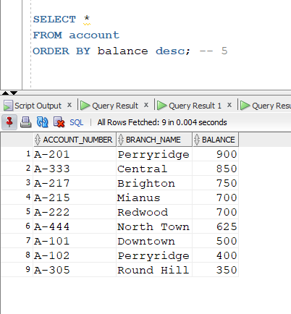

6) Display the customer related information in alphabetic order of customer cities. (order by clause)
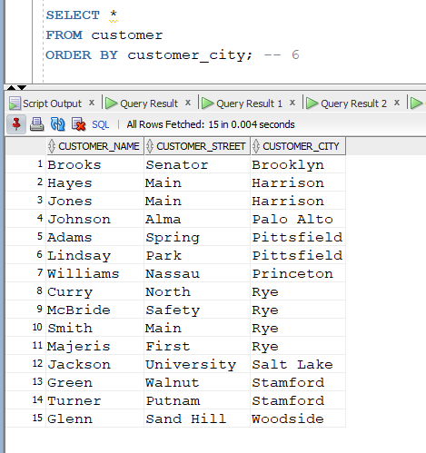
7) Find all customer names who have an account as well as a loan. (intersect)
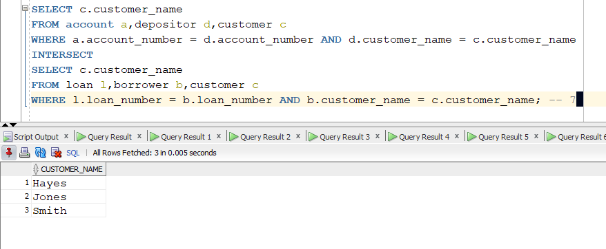
8) Find all customer related information who have an account or a loan. (union)
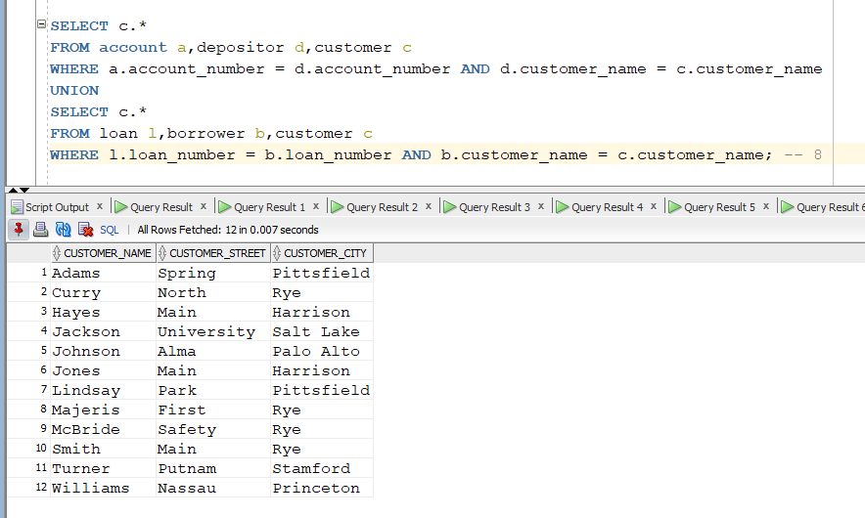
9) Find all customer names and their cities who have a loan but not an account. (minus)
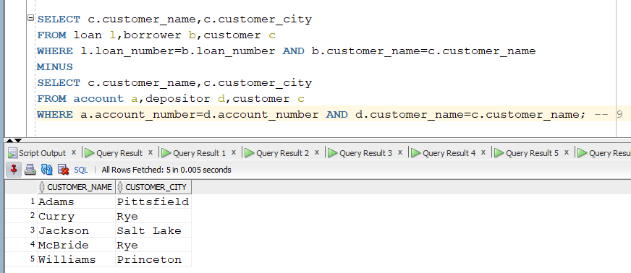
10) Find the total assets of all branches. (aggregate function)
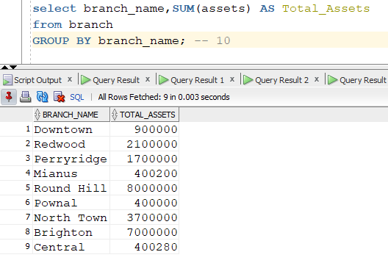
11) Find the average balance of accounts at each branch. (aggregate function)
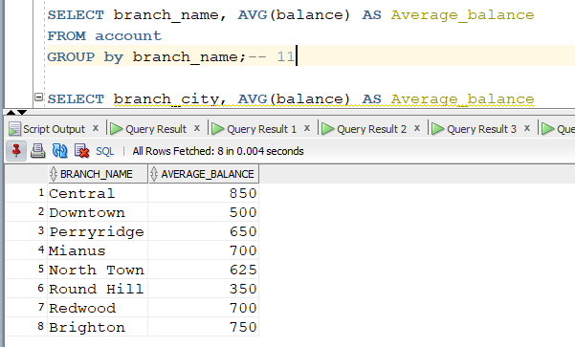
12) Find the average balance of accounts at each branch city. (aggregate function)
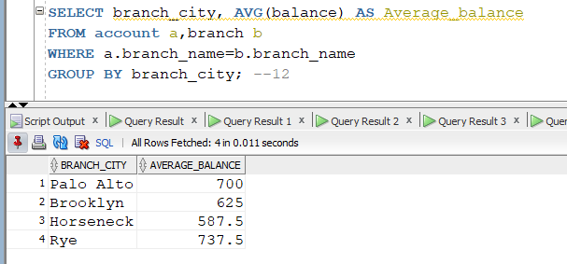
13) Find the lowest amount of loan at each branch. (aggregate function)
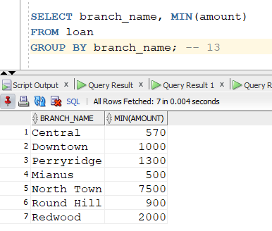
14) Find the total number of loans at each branch. (aggregate function)
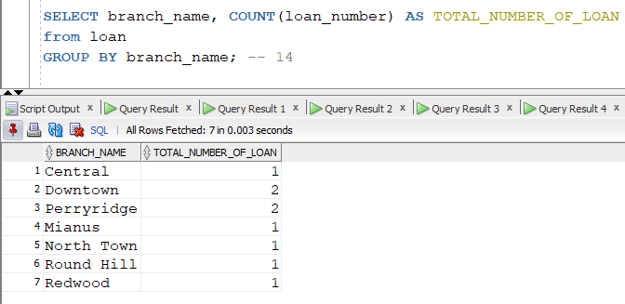
15) Find the customer name and account number of the account which has the highest balance. (aggregate function)
